Screen Shots

# Test 1



# Test 2

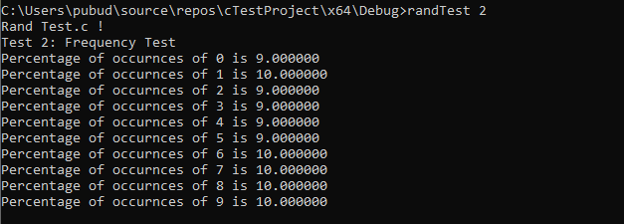

# Test 3

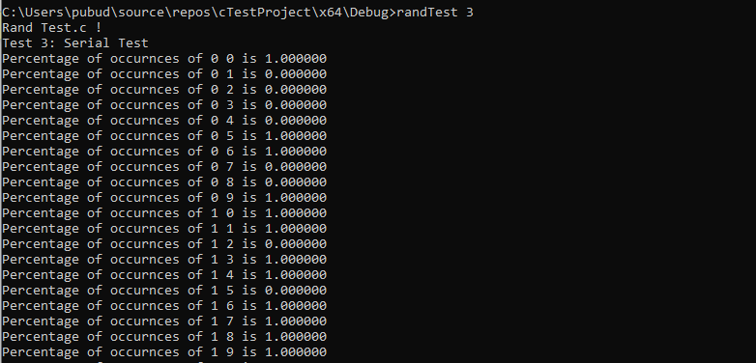

# Test 4

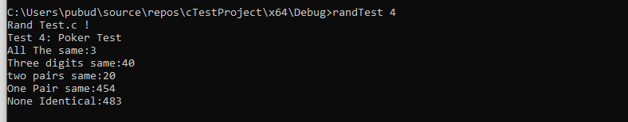

# Test 5

